YEAR 11 PHYSICS

SEMESTER 2 2005

Name:_________________________ Teacher: ________________

TIME ALLOWED FOR THIS PAPER

Reading time before commencing work: Ten minutes
Working time for paper: Three hours

MATERIAL REQUIRED/RECOMMENDED FOR THIS PAPER

TO BE PROVIDED BY THE SUPERVISOR

This Question/Answer Booklet
Physics Formulae and Constants Sheet
Sheet of standard graph paper

TO BE PROVIDED BY THE CANDIDATE

Standard Items: Pens, pencil, eraser, correction fluid and ruler

Special Items: Drawing instruments, templates and calculators satisfying the conditions set by the Curriculum Council.

IMPORTANT NOTE TO CANDIDATES

No other items may be taken into the examination room.

It is your responsibility to ensure that you do not have any unauthorised notes or other items of a non-personal nature in the examination room. If you have any unauthorised material with you hand it to the supervisor BEFORE reading any further.

STRUCTURE OF PAPER

Section | No. of questions | No. of questions to be attempted | No. of marks out of 200 | Proportion of examination total
A: Short Answers | 15 | ALL | 60 | 30%
B: Problem Solving | 7 | ALL | 100 | 50%
C: Comprehension and Interpretation | 2 | ALL | 40 | 20%

INSTRUCTIONS TO CANDIDATES

Write your answers in the spaces provided beneath each question. The value of each question (out of 200) is shown following each question.

The Physics Data Sheet must also be submitted with your exam.

Calculators satisfying the conditions set by the Curriculum Council may be used to evaluate numerical answers.

Answers to questions involving calculations should be evaluated and given in decimal form. Quote the final answer to no more than three significant figures. Despite an incorrect final result, credit may be obtained for method and working, provided these are clearly and legibly set out.

Questions containing specific instructions to show working should be answered with a complete, logical, clear sequence of reasoning showing how the final answer was arrived at; correct answers which do not show full working will not be awarded full marks.

Questions containing the instruction estimate may give insufficient numerical data for their solution. Students should provide appropriate figures to enable an approximate solution to be obtained.

SECTION A: Short Answers

Marks Allotted: 60 marks out of total of 200 marks (30%)

Attempt ALL 15 questions in this section. Each question is worth 4 marks. Answers are to be written in the space below or next to each question.

- Jane has been asked to give a short talk on sea breezes. Listed below are some key parts of her speech. Help her prepare the speech by choosing the best alternative for the options given.
In the following indicate the answer by circling the best choice from the bolded options.
Each correct ½ mark
“During hot summer days, [radiant/convective] energy from the sun heats the land and sea. The land, however, has a [lower/higher] specific heat capacity than the sea and soon has a [higher/lower] temperature than the water. The air near the ground becomes hot as a result of [convection/conduction]. As the air gets hot, it [contracts/expands], becoming [less/more] dense than the air over the sea. The air over the [land/sea] rushes in towards the[sea/ land], replacing the rising warm air, causing what is know as a sea breeze.”
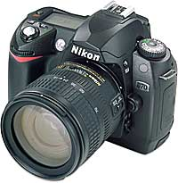
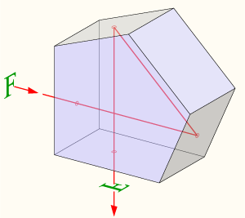
- A pentaprism is a five-sided reflecting prism used to deviate a beam of light by 90° in a single lens reflex camera. The beam reflects inside the prism twice, allowing the transmission of an image through a right angle without inverting it as an ordinary right-angle prism would. The diagram below shows a ray of light being reflected inside a pentaprism of refractive index 1.34.
Is the ray inside the pentaprism being reflected due to total internal reflection? Explain.
No. The reflections inside the prism are not caused by total internal reflection, since the beams are incident at an angle smaller than the critical angle of 48.3 degrees. . (Angle of incidence is 22.5º)
Instead, the two faces must be coated to provide mirror surfaces. 

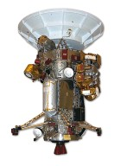
- The Cassini space probe (mass 5.5 x 10⁴ kg) was successfully launched onboard a TITAN IV rocket from Cape Canaveral on October 15, 1997 on a voyage to Saturn. The diagram below shows the deployed space probe moving at a constant velocity of 890 ms⁻¹ towards A. To change course, a sideways force is produced by firing the thruster. This increases the velocity towards B from 0 to 60 ms⁻¹ in 25 s. Determine the magnitude of the resultant velocity after 25 s
890ms⁻¹
R

60ms⁻¹
R² = 60² + 890²
⇨ R = 8.92 x 10² ms⁻¹ 
B
Thruster
A
- In terms of the energy of particles, explain why a sample of a volatile liquid such as methylated spirits, cools as the liquid evaporates?
In a sample of methylated spirits there are a range of kinetic energies of the particles. Some of these particles at the surface of the methylated spirits can escape if they have sufficient energy or they can fall back into the liquid. Since only the faster or higher energy particles escape, over time the average kinetic energy of the liquid is reduced, thus the temperature is less.
- A two resistor voltage divider is used often to supply a voltage different from that of an available battery or power supply. In application, the output voltage depends upon the resistance of the load it drives. The picture at right below shows a typical voltage divider, with connections made across different pin combinations resulting in different potential differences. The diagram below at left shows a simplified circuit diagram of the voltage divider
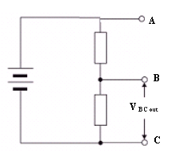  For this circuit , V_{IN} = 30.0 V, R₁ = 5.0 kΩ and the output voltage V_{BC OUT} = 6.0 V | 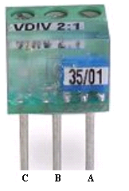
Calculate the value of the resistance R₂ in the circuit above?
V₂ = 24.0V 
By proportion 6.0V ⇨5.0 kΩ, thus 24.0V ⇨20.0 kΩ
OR
V₂ = 24.0V 
V₁ = I₁R₁
⇨6.0 = 5000 x I₁
⇨ I₁ = 1.2 x 10⁻³ A
Now V₂ = I₂ R₂
⇨ 24.0 = 1.2 x 10⁻³ x R₂
⇨R₂ = 20.0 kΩ
- Suppose in the laboratory you wanted to construct the circuit as shown in the diagram in question 5, but only have 20 kΩ resistors to work with. Explain how you could use 20kΩ resistors to create the equivalent resistance as a 5 kΩ resistor. Include a sketch to show the connections between the appropriate number of 20 kΩ resistors.
The R1 resistor needs to be constructed with four 20 kΩ resistors connected in parallel
 Diagram

- When referring to radiation dosage, gamma (γ) radiation and alpha (α) radiation have different quality factors.
  - State which type of radiation has the larger quality factor.
α-radiation 
  - Explain why, for the same absorbed dose, the radiations have different effects.
effect depends on ionization. α causes more ionization per unit length of its track. as it is large and can cause significant damage to cells as it transfers its energy.

- The diagram below shows a trampoline. Explain, in terms of momentum, why you do not hurt yourself when falling into the mat, but you would if you missed the mat and hit the ground?
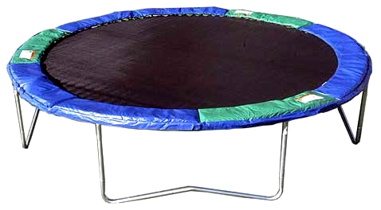
In hitting the mat, the time for you to undertake your change in momentum and come to rest is much larger than the time to stop in hitting the ground. In both cases the change in momentum is the same . Since force is inversely proportional to time, the greater the time the less the force.
- In terms of reflection and absorption of light, explain how the print on this page appears black on a white background.
The text absorbs the visible light and thus little light is reflected back into our eyes. This absence of light entering our eye is perceived as black. The background reflects all visible light that falls on. This light is reflected back into our eyes. This presence of all colours of light entering our eye is perceived as white.
- The football commentator says "Going into the half time break, the Dockers have the momentum." The headlines declare "Fremantle Gaining Momentum." The coach pumps up his team at half-time, saying "You have the momentum; the critical need is that you use that momentum and bury them in this third quarter." Compare this description of momentum with your understanding of what we mean when we talk about momentum in physics.
A team that has the momentum is on the move and is going to take some effort to stop. A team that has a lot of momentum is really on the move and is going to be hard to stop. If an object is in motion ("on the move") then it has momentum.All objects have mass; so if an object is moving, then it has momentum. The amount of momentum which an object has is dependent upon two variables: its mass and how fast the mass is moving. Momentum depends upon the variables mass and velocity. In terms of an equation, the momentum of an object is equal to the mass of the object times the velocity of the object.
- Sodium-24 has a half life of 15 hours. A 45.0 g sample is flushed into a pipe line. How much will remain unchanged after one day?
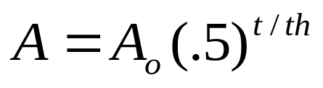
⇨ A = 45 (.5) ^{24/15}
⇨ A = 14.8 g 

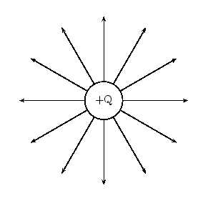
- Sketch the electric field that exists around a single isolated positive charge and use this diagram to explain what an electric field actually is?
The electric field is a zone of influence around the positive charge in which another small positive will experience a force of repulsion.
Diagram 

- The back of a Western Power electricity bill is shown below. Study the bill and answer the following questions.
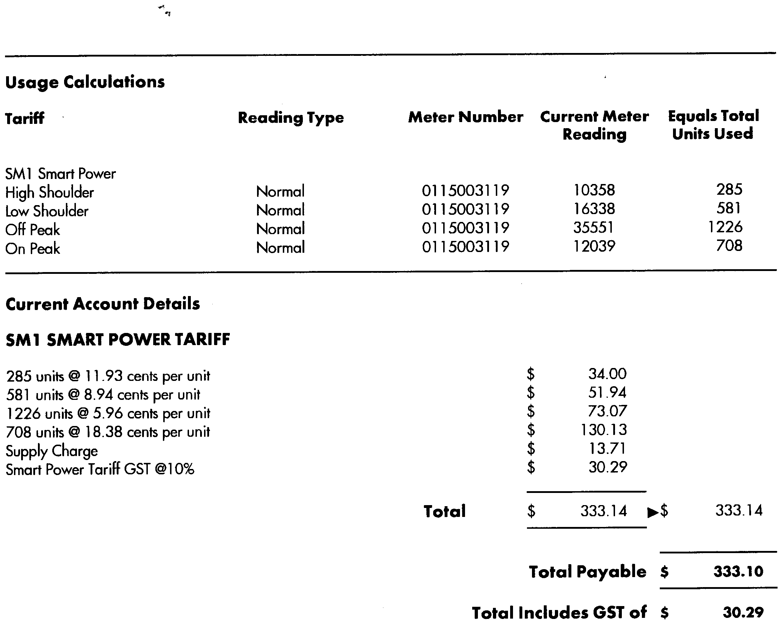
  - What is meant by the word ‘unit’ in this bill?
A kilowatt hour
  - Why does Western Power charge different rates depending on when the electricity is used (i.e. off peak and on peak)?
Western Power is trying to encourage people to use electricity during “off peak” time so as to even out demand for electricity
”Peak” time would coincide with the time that industry and business is operating and “Off peak” time would be when industry is not operating 
By decreasing the demand at “Peak” times the Western Power does not have have to build new power stations. 
- Sam repairs the cord on an electric kettle, but he mistakenly swapped the active and the neutral around. Is the kettle still capable of heating water and is it safe.
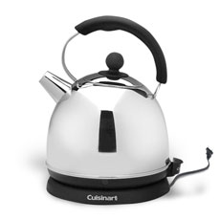
Yesthe kettle will still heat the water. This arrangement however is not safe as the wall switch is on the active line and even when it is turned off there is the possibility electrocution should an internal wire come loose. 

  - What are radioisotopes?
An unstable isotope of an atom that becomes more stable by the emission of an alpha, beta or gamma ray (Radioactive isotope – 1 mark)
  - Describe one medical and one non medical use of radioisotopes.
Medical- cancer therapy, tracers etc
Non medical- thickness measuring, mass and volume of opaque containers, detecting leaks in pipes etc

THIS PAGE HAS BEEN LEFT INTENTIONALLY BLANK
SECTION B: Problem Solving

Marks Allotted: 100 marks out of total of 200 marks (50%)

This section contains 7 questions. You should answer ALL of the questions and show full working.

Answer all questions in the spaces provided.

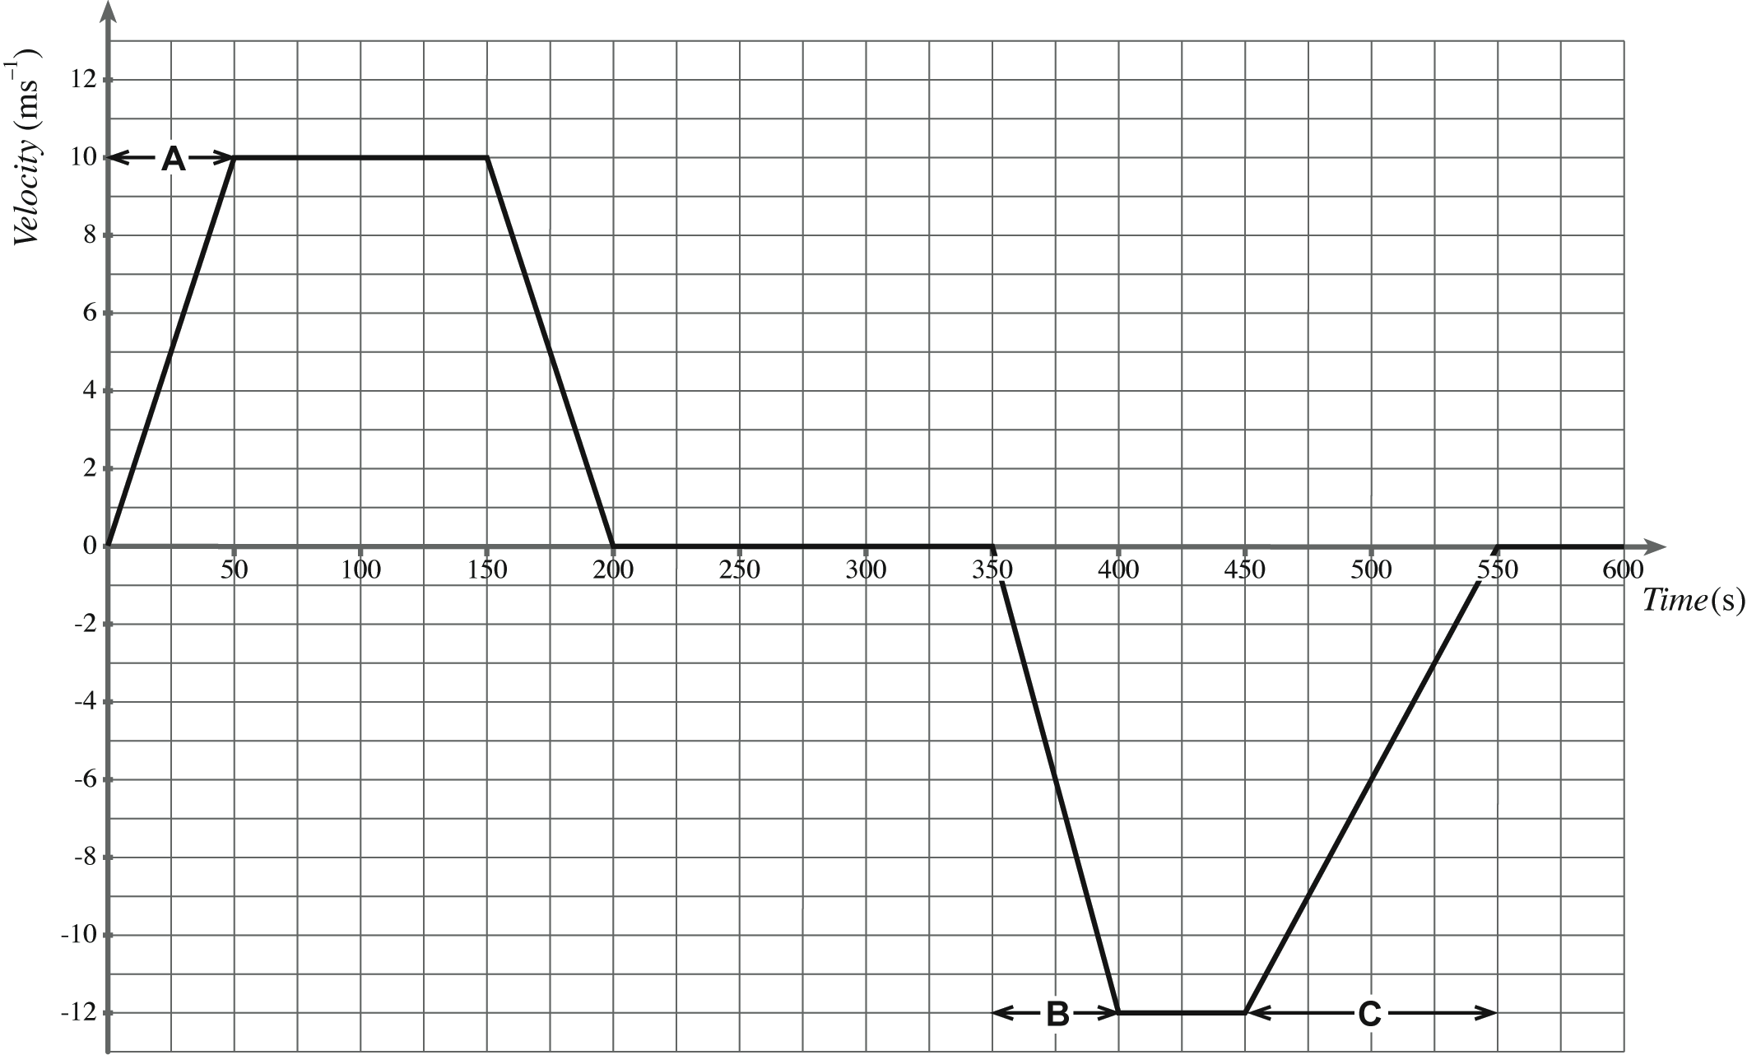
- [10 marks]
On a school ski trip, a mini-bus transports passengers between the car park and the ski centre. The bus starts from the car park and travels north to the ski centre, drops off the passengers and returns to the car park. The velocity–time graph for the bus journey is given below.
Time (s)
Velocity
(ms⁻¹)
  - The time taken by the bus to travel from the car park to the ski centre is 200 seconds. From the graph, calculate the distance travelled by the bus from the car park to the ski centre.
[2 marks]
Distance = area under graph
⇨ Distance = ½( 50 x10) + (100 x 10) + ½( 50 x10)
⇨ Distance = 250 +1000+250
⇨ Distance = 1.50 x 10³ m
  - From the graph, show that the acceleration of the bus during section A of its journey is 0.20 ms^{–2}.
[1 mark]
a = slope of line
⇨ a = rise/run
⇨ a = 10/50
⇨ a = 0.20 ms⁻¹
  - The mass of the bus is 2250 kg. The combined mass of the driver and the passengers is 800 kg. Calculate the force required to produce the acceleration of 0.20 ms^{–2}, during section A of its journey.
[1 mark]
F =ma
⇨ F = (2250+800)0.2
⇨ F = 610 N
After unloading the passengers at the ski centre, the bus now travels back to the car park with some tourists.
  - Explain why the second part of the graph is drawn below the time axis.
[1 mark]
Bus is now heading in the opposite direction to the initial journey
  - Describe the motion of the bus during section B of its journey.
[1 mark]
Constant acceleration of 0.24 ms-2 (12/50) back towards the car park
  - The unbalanced force acting on the bus during section C of its journey is 342N. Estimate the number of passengers in the bus.
[4 marks]
a = rise/run ⇨ a = 12/100 ⇨ a = 1.20 ms⁻²
F = ma
⇨ 342 = m x 1.20
⇨ m = 2850 kg
Mass of passengers = 2850-2250
⇨ Mass = 600 kg 
Estimate mass of one passenger is 65 kg
⇨Number = 600/65
⇨ Number = 10

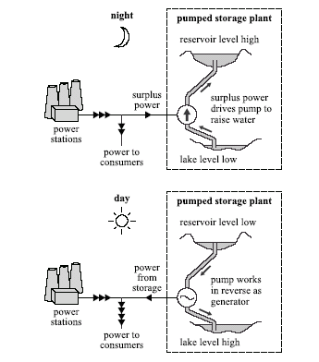
- [12 marks]
The diagram below shows the principle of a hydroelectric pumped storage plant. During times when there is a low demand for electricity, the spare capacity of other power stations is used to pump water from the lake into the reservoir. The potential energy of the water is then converted into electricity when needed to satisfy peak demand
Other power
stations
Other power
stations
For this plant the water falls an average distance of 370 m between the reservoir and the generator. The mass of water stored in the reservoir when it is full is 1.0 x 10¹⁰ kg.
  - Show that the useful gravitational potential energy stored when the reservoir is full is about 4.0 x 10¹³ J.
[2 marks]
E_{p} = mgh
⇨ E_{p} = 1.0 x 10¹⁰ x 9.8 x 370
⇨ E_{p} = 3.60 x 10¹³ J
  - Calculate the speed of the water as it reaches the generator assuming that no energy is lost as the water falls.
[2 marks]
Loss in Ep = gain in Ek
⇨ ½ v² = gh
⇨ v = 84.9 ms⁻¹
  - The pumped storage plant has four 100MW generators. Calculate the longest time, in hours, for which the stored energy alone could provide power at maximum output. Assume that all the stored gravitational potential energy can be converted into electrical energy.
[3 marks]
E = Pt or t = ½ mv²/P or numerical substitution
i.e. time = 3.6 x 10¹³/400 x 10⁶
⇨ time = 9.0 x 10⁴ s (25 hours)

  - Using the answer from c) above, what maximum income could the plant receive from electricity sales if the wholesale price of electricity is 10.5 cents per unit?
[2 marks]
No of units = 4 x 100 000 x 25.0
⇨ No = 1.0 x 10⁹
⇨ Income = 1.0 x 10⁹ x 10.5
⇨ Income = 1.05 million

  - In practice not all the stored energy that is put into the system during the night can be retrieved as electrical energy during the day. State and explain how energy is lost in the system.
[3 marks]
Energy is “lost” by being transferred into useless forms of energy. In pumping water into a reservoir, the useful energy is gravitational potential energy whilst wasted energy is heat and sound generated by the pump.
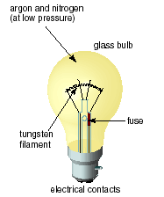
- [15 marks]
In an incandescent bulb, the filament is made of a thin piece of tungsten metal, coiled to fit inside the bulb. When a current passes through the filament, it heats up and gives off visible light.
  - On the axes below, draw a sketch-graph to show how the current (I) in the filament lamp varies with potential difference (V) as the switch is turned on and the voltage increases to a maximum. (Note: this is a sketch-graph; you do not need to add any values to the axes).
[2 marks]
Any reasonable curve in the right direction
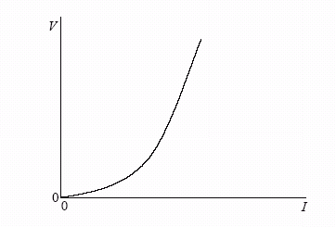
  - Explain how the resistance of the filament is determined from the graph.
[2 marks]
From the gradient of the graph at that particular point or from the value of V/I at any point on the curve . (Don’t accept just V/I)
  - Explain whether the graph you have sketched indicates ohmic behaviour or non-ohmic behaviour.
[2 marks]
non-ohmic because the resistance (V/I at each point) is not constant

A filament lamp operates at maximum brightness when connected to a 6.0 V supply. At maximum brightness, the current in the filament is 120 mA.
  - Calculate the resistance of the filament when it is operating at maximum brightness.
[2 marks]
V =I R
⇨ 6.0 = 0.12 x R
⇨ R = 6.0/0.12
⇨ R = 50.0Ω
  - If the wire that makes up the filament has a diameter of 1.6 x 10⁻⁵ m, calculate the length of the tungsten in the globe.
[4 marks]
A= πr²
⇨ A = π(1.6 x 10⁻⁵/2)²
⇨ A = 2.01 x 10⁻¹⁰ m² 
R = ρl/A
⇨ 50 = (5.5 x 10⁻⁸ x l)/ 2.01 x 10⁻¹⁰
⇨ l = 1.83 x 10⁻¹ m
  - Suppose the tungsten wire was replaced by an identically sized and length of copper wire. What would you observe when the light was switched on. Explain.
[3 marks]
Since the resistivity of copper is less than that of tungsten, the resistance of the wire would be less and thus the current greater. Since P = VI, the globe will glower brighter, be hotter and could possibly burn out.

- [16 marks]
  - Explain the term nucleon.
[1 mark]
A proton or a neutron found in the nucleus 
  - Explain the term nuclear binding energy.
[1 mark]
The difference between the mass of the nucleus and the sum of the masses of its individual nucleons / the energy required to separate a nucleus into its component nucleons 
The axes below show values of mass number (A) on the horizontal axis and average binding energy per nucleon (E) in MeV on the vertical axis. (Binding energy is taken to be a positive quantity).
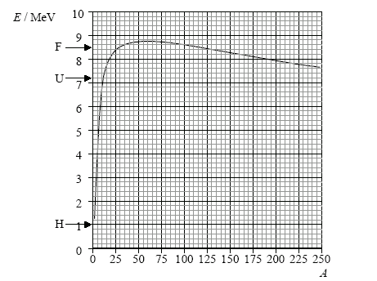
  - Without calculating the values, mark on the E axis above, the approximate position of
    - the isotope 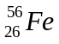(label this F). between 8 and 9 [1 mark]
    - the isotope 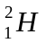 (label this H). between 1 and 2 [1 mark]
    - the isotope 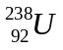 (label this U) between 7 and 8 [1 mark]
  - Using the grid above, draw a graph to show the variation with mass number A of the average binding energy per nucleon E.
[2 marks]
  - Use the data in the data sheet to determine the binding energy per nucleon of the isotope is 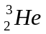.
[3 marks]
mass of nucleons =(2 x 1.00728) + 1.00867 = 3.02323 u
mass difference =0.0072 u = 6.7 MeV
binding energy per nucleon 6.7/3 =2.2 MeV 

In the nuclear reaction
+ ⇨ + 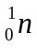
energy is released.
  - State the name of this type of reaction.
[1 mark]
Fusion
  - Use your graph from d) above to explain why energy is released in this reaction.
[3 marks]
From the position on the graph, the energy required to assemble two nuclei of is greater than that to assemble one nucleus of ; hence if two nuclei of combine to form one nucleus of energy must be released 

  - Why are high temperatures needed to make the nuclear reaction above self-sustaining?
[2 marks]
Since the nuclei each have a positive charge, they are naturally repelled from each other. High temperatures are needed to give the nuclei sufficient energy to overcome this force of repulsion.
- 19 marks]
Lisa conducts an experiment in the science laboratory in order to produce a heating curve. A quantity of crushed ice is removed from a freezer, dried with a paper towel, and placed in a calorimeter. Thermal energy is supplied to the ice at a constant rate and it is continually stirred. The temperature of the contents of the calorimeter is recorded every 15 seconds. The graph below shows the variation with time t of the temperature T of the contents of the calorimeter.
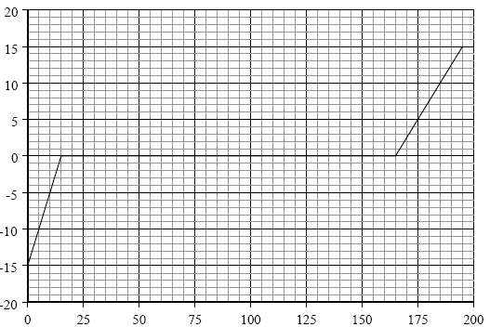
T ( ºC)
t (s)
  - On the graph above, mark with an X, the data point on the graph at which all the ice has just melted.
[1 mark]
  - Explain, with reference to the energy of the molecules, the constant temperature region of the graph.
[4 marks]
To change phase, the separation of the molecules must increase; Some recognition that the ice is changing phase is needed. so all the energy input goes to increasing the PE of the molecules; Accept something like “breaking the molecular bonds”. KE of the molecules remains constant, hence temperature remains constant; If KE mentioned but not temperature then assume they know that temperature is a measure of KE.

  - The mass of the ice that Paul used was 0.25 kg. Use this data and data from the graph to determine the power of the heater.
[4 marks]
time for water to go from 0 to 15 C ° = 30 s; 
energy required = mcΔt
⇨ Q = 0.25 x15x 4 200 =15 750 J; 
power = energy/time
⇨ P = 15 750/30
⇨ P 525 W 

  - From the data supplied determine the specific heat capacity of ice.
[4 marks]
ice takes 15 s to go from -15 C ° to 0 C
energy supplied 15 x 525 = 7.88 x 10³J
Q = mcΔt
⇨ 7.88 x 10³ = 0.25 x c x 15
⇨ c = 2.10 x 10³ J kg⁻¹ K⁻¹

  - Why was it necessary for the ice to be continually stirred?
[2 marks]
The solution needs to be continually stirred in order to ensure that heat is transferred to the ice first and does not heat the iced water

  - Why was the ice dried before it was placed in the calorimeter?
[2marks]
To remove water so that the heat supplied first of all melts the ice rather than heating the water

  - Suppose that the ice had not been dried prior to being placed in the calorimeter. How would this have affected the value for the specific latent heat of fusion of ice that you calculated above? Explain.
[2 marks]
The mass of ice is less than 0.25 kg, with some some of it being liquid water which has a higher specific heat capacity. Assuming that there is an even distribution of energy to the ice and water, the calculated value of Q is less than it should actually be.
Thus the power calculated is less than it should be , so more energy is actually given to the lower mass of ice to melt, thus the value of L calculated is too low. The actual value of L should be higher.
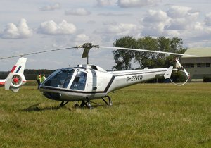
- [15 marks]
A helicopter such as the one shown at right has a mass of 5000 kg and is sitting on the ground with its engines idling, producing a lift force of 1.60 x 10⁴ N.
a. Calculate the normal reaction force of the ground on the helicopter. [2 marks]
F_{L} + F_{R} = mg
⇨ 1.60 x 10⁴ + F_{R} = 5000 x 9.8
⇨ F_{R} = 3.30 x 10⁴ N up
b. The pilot now increases the speed and tilt of the rotors, so that the lift force becomes 6.00 x 10⁴ N. Calculate the upwards acceleration of the helicopter. [3 marks]
F_{R} = lift – weight
⇨ F_{R} = 6.00 x 10⁴ – 5000 x 9.8
⇨ F_{R} = 1.10 x 10⁴ N 
now F = ma
⇨ 1.10 x 10⁴ = 5000 a
⇨ a = 2.20 ms⁻²
c. If the helicopter continues to accelerate at this rate, how long will it take to reach a height of 350m? [2 marks]
s = ut + ½ at²
⇨ 350 = 0 + ½ 2.20 x t²
⇨ t = 17.8 s
d. What will be its speed at 350m altitude? [2 marks]
v = u +at
⇨ v = 0 + 2.20 x 17.8
⇨ v = 39.2 ms⁻¹ 
Just as the helicopter reaches the height of 350m, a loose bolt dislodges from its undercarriage and eventually falls to the ground below.
- In which direction does the bolt move initially? [1 mark]
up

- Calculate how long the bolt takes to reach the ground. [3 marks]
s = ut + ½ at²
⇨ -350 = 39.2 t - 4.9t²
⇨ t = 13.4 s

- With what speed does the bolt actually strike the ground?
[2 marks]
v² = u² + 2as
⇨ v² = 39.2² + 2 (-9.8) x (-350)
⇨v = 91.7 ms-1 
- [13 marks]
Giles and Sally conduct an experiment in Physics to find the relationship between the angle of incidence i and the angle of refraction r of a light ray travelling from air to glass. Their experimental setup is shown below.
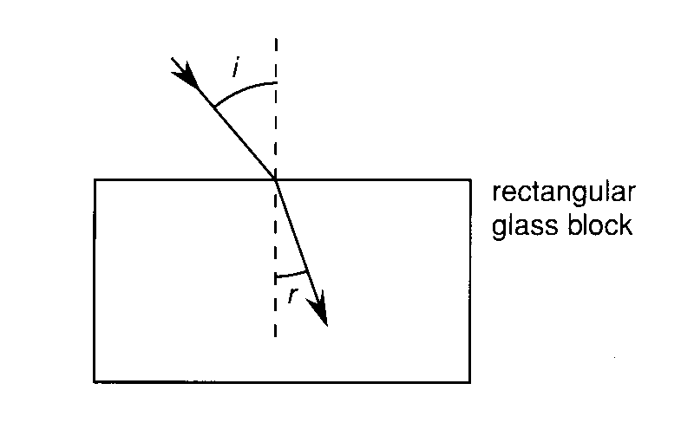
The results obtained are shown below.
Angle of incidence (º) | Angle of refraction (º) | Sin i | sinr
50.0 | 31.0 | 0.766 | 0.515
40.0 | 26.0 | 0.643 | 0.438
32.0 | 21.0 | 0.530 | 0.358
22.0 | 15.0 | 0.375 | 0.259
10.0 | 8.0 | 0.174 | 0.139
Theory tells us that for the situation above
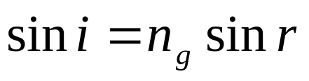
where n_{g} is the refractive index of the glass block.
  - Modify the data above so that you can plot a linear (straight line) graph and enter this data into the table.
[1 mark]
  - Using the included graph paper, plot the linear graph.
[4 marks]
 labels + units
 points

  - Describe how you could determine the refractive index of the glass block from your graph
[3 marks]
The relationship is in the form of y = mx, so a graph of Sin i (y) against sin r (x) will yield a straight line of gradient n.
  - From the graph, determine the refractive index of the glass block?
[2 marks]
From the graph n = the gradient which is 1.56
  - Which set of readings is likely to yield the greatest percentage error
[1 mark]
i = 10º, r = 8º

    - Complete the ray diagram below to show the path of the light rays as it emerges from the glass block.
 [1 mark]
    - What can you say about the direction of the emerging ray and the ray that is incident on the glass block?
[1 mark]
They are parallel. 
SECTION C: Comprehension

Marks Allotted: 40 marks out of total of 200 marks (20%)

This section contains TWO questions. You should answer BOTH of the questions.

Read the following passages and answer the questions at the end of each. Candidates are reminded of the need for clear and concise presentation of answers. Diagrams (sketches), equations and/or numerical results should be included as appropriate.

Question 1:

Walk into almost any business office, and you'll probably find a photocopier ("copier") with a line of people waiting to use it. For most businesses, small or large, the copier has become standard equipment, much like having a desk to work at and a chair to sit in.
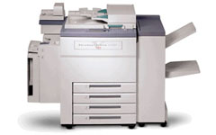

What happens inside the copier at this point is amazing! At its heart, a copier works because of one basic physical principle: opposite charges attract. As a kid, you probably played with static electricity and balloons. On a dry day, you can rub a balloon on your jumper and create enough static electricity in the balloon to create a noticeable force. For example, a balloon charged with static electricity will attract small bits of paper or particles of sugar very easily.

A copier uses a similar process.
- Inside a copier there is a special drum. The drum acts a lot like a balloon – you can charge it with a form of static electricity.
- Inside the copier there is also a very fine black powder known as toner. The drum, charged with static electricity, can attract the neutral toner particles.
There are three things about the drum and the toner that let a copier perform its magic:
- The drum can be selectively charged, so that only parts of it attract toner. In a copier, you make an “image” – in static electricity – on the surface of the drum. Where the original sheet of paper is black, you create static electricity on the drum. Where it is white you do not. What you want is for the white areas of the original sheet of paper to NOT attract toner. The way this selectivity is accomplished in a copier is with light – this is why it’s called a photocopier!
- Somehow the toner has to get onto the drum and then onto a sheet of paper. The drum selectively attracts toner. Then the sheet of paper gets charged with static electricity and it pulls the toner off the drum.
- The toner is heat sensitive, so the loose toner particles are attached (fused) to the paper with heat as soon as they come off the drum.
The drum, or belt, is made out of photoconductive material. Here are the actual steps involved in making a photocopy:
- The surface of the drum is charged to a charge of about +0.25 nC.
- An intense beam of light moves across the paper that you have placed on the copier’s glass surface. Light is reflected from white areas of the paper and strikes the drum below.
- Wherever a photon of light hits, electrons are emitted from the photoconductive atoms in the drum and neutralize the positive charges above. Dark areas on the original (such as pictures or text) do not reflect light onto the drum, leaving regions of positive charges on the drum’s surface.
- Black pigment called toner is then spread over the surface of the drum, and the pigment particles adhere to the positive charges that remain.
- A sheet of paper positively charged to about 0.1 nC then passes over the surface of the drum at a distance of 1.0 mm, attracting the beads of toner away from it.
- The paper is then heated and pressed to fuse the image formed by the toner to the paper’s surface.

  - What is meant by the term “opposite charges attract” ? [2 marks]
This means that a positive and negative charge will experience a force that will try and move them closer to each other.
  - Why is a “dry day” necessary to demonstrate static electricity?
[2 marks]
The air must be dry otherwise water molecules in the air will neutralise the charge quickly as they are attracted to any charged surface.
  - Explain how toner can be attracted to the drum when the toner is neutral.
[3 marks]
.Many particles are made up of molecules which have one end slightly positive and the other slightly negative. The separation of charge means that the opposite end will always experience a force of attraction  grater than the same charge as it will be closer or rotate to be closer.

  - Explain what is meant by saying that a photocopier drum is selectively charged.
[2 marks]
Only parts of the drum remain charged. This is where the reflected light has not hit

  - How many electrons need to be removed from the drum in order to produce a charge of 0.25 nC? [3 marks]
Charge on an electron is -1.6 x 10⁻¹⁹ C
n_{e} = 0.25x 10⁻⁹/1.6 x 10⁻¹⁹
⇨ n_{e} = 1.56 x 10 ⁹
  - How are regions of positive charge produced on the drum?
[3 marks]
The surface of the drum is charged positively. Light from white areas on the original are reflected onto the drum
Photons of light emit electrons from the photoconductor atoms in the drum, neutralizing the positive charge in those areas. Dark areas leave regions of positive charge.

  - Estimate the force of repulsion that would exist between the positively charged paper going into the drum and the drum itself. [4 marks]
F = kq₁q₂/d²
⇨ F = 9 x10⁹ x 0.1 x 10⁻⁹ x 0.1 x 10⁻⁹/(1 x 10⁻³)²
⇨ F = 2.25 x 10⁻⁴ N

  - In actual fact, the force is much less that you have calculated in g). Why would this be the case?
[3 marks]
This assumes that all the charge is concentrated at one point for each of the surfaces, but in fact it is spread out over a large distance so that much of the charge is separated by more than 1 mm

THIS PAGE HAS BEEN LEFT INTENTIONALLY BLANK
Question 2:
Until relatively recently, "huge screen TV" meant pretty much one thing: a rear-projection cathode ray tube (CRT) set. But if you go to the electronics store today, you'll see several big screen options - plasma, liquid crystal display (LCD) and digital light processing (DLP) television.
DLP sets are an attractive option because they're a lot cheaper than flat panel plasma and LCD sets of the same size. They also have a better picture and are less bulky than conventional CRT sets.
Pixels and Mirrors
At the heart of the DLP system is a digital micromirror device (DMD). The DMD is tiny, you could hold it in the palm of your hand. But if you could get a close-up look at one while it was working, what you would see would resemble a photo mosaic.
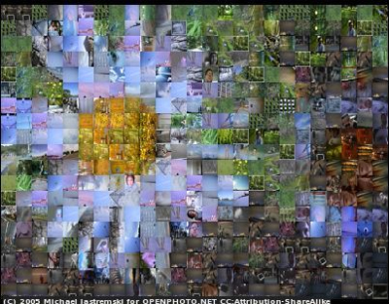
Photo courtesy Michael Jastremski for openphoto.net
Colour Blue Mountain Flower Mosaic
When you look closely at a photo mosaic, you see a group of tiny, square photographs. But when you step away from the mosaic, the photos blend together to create a larger image. This is what happens with a DMD, except that it uses light instead of tiny photographs. If you looked at it very closely, you would only see tiny, square mirrors reflecting light. But, from far away (or when the light is projected on a screen), you would see a picture.
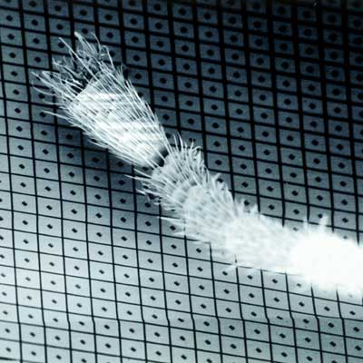
Photo courtesy Texas Instruments
The leg of an ant rests on this DMD mirror array
A DMD contains as many as two million microscopic mirrors, and each mirror corresponds to one pixel of the finished picture. The aluminium mirrors are sixteen microns square and weigh only a few millionths of a gram. Each one is attached to a yoke and a hinge that moves the mirrors to the on and off positions.
In addition to the mirrors, the DMD unit includes:
- A CMOS DDR SRAM chip, which is a memory cell that will electrostatically cause the mirror to tilt to the on or off position.
- A heat sink
- An optical window, which allows light to pass through while protecting the mirrors from dust and debris
Creating a Picture
Before any of the mirrors switch to their on or off positions, the chip rapidly:
- Decodes the incoming signal
- Converts interlaced data to progressive data
- Sizes the picture to fit the screen
- Makes any necessary adjustments to the picture, including brightness, sharpness and colour quality
- Converts colour information to red, green and blue (RGB) format
It then digitally relays all the information to the mirrors. If the size of the image contains fewer pixels than the DMD supports, then the chip simply ignores the unneeded mirrors.
When the set is off, all of the mirrors are flat. When someone turns the set on and the chip begins transmitting the signal, the mirrors flip back and forth thousands of times per second. They move between +10° and -10° in older DMDs, or between +12° and -12° in newer DMDs. Newer DMDs also use "dark metal" on the aluminium mirrors whose function is similar to the dark pigments in the retina of the human eye.
Mirrors in the on position reflect the light through a projection lens and onto the screen. By varying the length of time that the mirrors point toward the projection lens, the DMD creates up to 1,024 shades of gray.
The grey pixels combine on the screen to create a fully digital monochrome image
Adding Colour
To add colour to the picture, the DLP system uses a colour wheel.
The colour wheel does exactly what its name implies. It's a transparent, spinning wheel with coloured segments. The light passing through each section turns the colour of the segment.
The system's processor synchronizes the spinning of the wheel with the action of the mirrors. Together, the DMD and the colour wheel can create 256 shades of each primary colour.
Each pixel of light on the screen is red, green or blue at any given moment. The DLP technology relies on the viewer's eyes to blend the pixels into the desired colours of the image. With this system, the DLP is capable of creating 16 million colours.
The Rainbow Effect
Most people's eyes do such a good job of blending colours that individual red, green and blue pixels go unnoticed. However, some people experience a "rainbow effect" when watching a DLP projection, especially when they change their focus from one part of the image to another. They may see the individual component colour s or may just sense a shimmering in the picture. This happens only in DLP systems that use a segmented colour wheel, not in systems that use one DMD for each primary colour .
A number of home theatre systems use colour wheels with additional segments to try to reduce the rainbow effect. Many use wheels with two segments of each colour. Some systems also add a dark green colour segment to improve the colour quality. Another option, sequential colour recapture (SCR), uses primary colours arranged in a spiral instead of in segments.
Once the DMD has created a picture out of light and the colour wheel has added colour , the light passes through a lens. The lens projects the image onto the screen.
Quality and Reliability
Considering its size and its vast number of parts -- as many as two million microscopic, moving mirrors -- it seems unreasonable to expect that a DLP system would actually work. Instead, it seems more likely that the parts would break or the mirrors would get stuck, especially since each part can make billions of movements and contacts during its lifetime.
So what keeps a DMD from breaking or falling apart? There are three major components that keep them together:
- Hinges.
- An anti-stick layer and spring-like contacts.
- Hermetic seals.

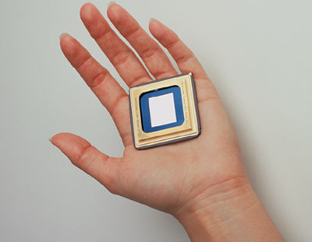
Photo courtesy Texas Instruments
A DMD Chip is small but sturdy

  - What does the author mean by saying that the mirrors are made to tilt electrostatically?
[2 marks]
By charging the upper and lower portions of the hinge with either the same or different charges of varying magnitudes, it can be made to move by electrostatic repulsion or attraction
  - Newer DMDs can tilt through a greater angle than older DMDs. How would this affect the image produced?
[2 marks]
The increase of the angle from 10° to 12° DMDs allows more light to reach the screen, producing a brighter picture. 
  - What would be the advantage of the “dark metal” used in newer DMDs
[2 marks]
To absorb stray light and create a clearer picture.

  - What type of lens is the projection lens and what type of image would it produce?
[2 marks]
Convex and a real image is formed
  - How are shades of gray are produced by the DMD ?
[3 marks]
The longer a mirror is in the on position, the lighter the pixel it creates. Mirrors that are off for longer periods create darker pixels, and mirror that are always off create black pixels.
  - What colours make up the spinning wheel?
[2 marks]
red, green and blue
  - How might the DMD produce the colour yellow?
[2 marks]
The DMD will reflect light from only the red and green segments of the color wheel while ignoring the blue segment. 
  - Describe how the rainbow effect occurs?
[2 marks]
When you change your focus from one part of the projected image to another you can see the individual component colours or a shimmering in the picture.
  - Describe how the three major components that keep the DMDs together work [2 marks]
Any 2  each
Hinges a flexible support
Anti stick layer keeps them from sticking to the landing surface.
Seals keep dust out.

ACKNOWLEDGEMENTS

SECTION C

Question 1: How photocopiers work in http://electronics.howstuffworks.com/photocopier.htm

Question 2: How DLP sets work in http://electronics.howstuffworks.com/dlp.htm

